VAR

Holden, K. (1995), Vector auto regression modeling and forecasting. J. Forecast., Vol. 14: 159–166

The attraction of Sims's methodology is that the VAR model is viewed as an unrestricted reduced form from a structural model. If, as Sims argues, the restrictions usually imposed on economic models from economic theory are invalid, it is better to ignore them and let the data determine the model. However, should those restrictions be valid, there will be a loss of efficiency in ignoring them.

Pp 164:

One area of controversy since Sims (1980) is whether the variables included in a VAR should be stationary or not. Sims includes the levels of such non-stationary variables as money and prices while other researchers (for example, Lupoletti and Webb, 1986) transform the variables to be stationary by forming rates of change. However, the development of tests for stationarity and the interest in cointegration following the work of Engle and Granger (1987) and Engle and Yoo (1987) has clarified the situation and Robertson and Wickens (1994) provide an up-to-date review.

If all the variables under consideration are stationary (which can be checked by the Dickey and Fuller, 1981, test) then the VAR should be estimated with these variables. Any shocks to stationary variables can have only a temporary eflfect.

When the variables are not stationary the situation is rather more complicated since the procedure depends on whether the variables are cointegrated. If they are not cointegrated, the correct approach is to transform the variables to become stationary (usually by first-differencing them) and then estimate the VAR in the usual way. But care must be taken in interpreting shocks because for first-diflferenced variables a shock will have a temporary eflfect on the change of the variable and a permanent eflfect on its level.

Vector Autoregressions. (2001).James H. Stock and Mark W. Watson

<http://www.google.com/url?sa=t&rct=j&q=&esrc=s&source=web&cd=2&ved=0CDQQFjAB&url=http%3A%2F%2Ffaculty.washington.edu%2Fezivot%2Fecon584%2Fstck_watson_var.pdf&ei=AQKhUvLgDpKShgfquoGQDQ&usg=AFQjCNFyE8yFGSAn1hZ--NZmx44bqB_yog&bvm=bv.57155469,d.ZG4&cad=rja>

Two decades ago, Christopher Sims (1980) provided a new macroeconometric framework that held great promise: vector autoregressions (VARs). A univariate autoregression is a single-equation, single-variable linear model in which the current value of a variable is explained by its own lagged values. A VAR is a *n*-equation, *n*variable linear model in which each variable is in turn explained by its own lagged values, plus current and past values of the remaining *n*-1 variables. This simple framework provides a systematic way to capture rich dynamics in multiple time series, and the statistical toolkit that came with VARs was easy to use and interpret. As Sims (1980) and others argued in a series of influential early papers, VARs held out the promise of providing a coherent and credible approach to data description, forecasting, structural inference, and policy analysis.

|  |
| --- |
| **Please use this identifier to cite or link to this item: http://purl.umn.edu/13527** |

|  |  |
| --- | --- |
| Title: | A BEGINNER'S GUIDE TO VECTOR AUTOREGRESSION |
| Authors: | Ford, Stephen A. |
| Issue Date: | 1986 |
| Series/Report no.: | Staff Paper P86-28 |
| URI: | http://purl.umn.edu/13527 |
| Institution/Association: | University of Minnesota>Department of Applied Economics>Staff Papers |

The forecasting ability of this model obviously depends on the economic structure imposed on the data a priori. This structure may not, however, represent exactly the true forces at work in the market. It also does not allow the dynamics of the market to enter the model other than in the expectations for the exogenous variables; input prices and disposable income. Additionally, the model is highly dependent on the method of generating expectations for these exogenous variables.

The main development of VARs as a modelling tool was in the early 1980s, originating from concerns about the validity of some of the assumptions used in traditional macroeconometric models. In particular, Sims (1980)(1) argued that the restrictions used to identify the parameters in traditional models—which often took the form of excluding variables or their lags from equations, or assuming that a particular variable was exogenous—were ‘incredible’. He contended that theory was rarely sufficiently well defined to justify such exclusion restrictions or exogeneity assumptions,(2) and that such models were likely to be under-identified once these problems were taken into account. As a result, some of the economic interpretations drawn from such models were unlikely to be robust

<http://www.google.com/url?sa=t&rct=j&q=&esrc=s&source=web&cd=6&ved=0CFQQFjAF&url=http%3A%2F%2Fwww.bankofengland.co.uk%2Fpublications%2FDocuments%2Fother%2Fbeqm%2F1999%2Ffive.pdf&ei=AQKhUvLgDpKShgfquoGQDQ&usg=AFQjCNGLD-McBfpnTSf3LN4C4TjW8nDSyA&bvm=bv.57155469,d.ZG4>

These concerns led to the development of VARs as an alternative modelling approach. VARs are dynamic systems of equations in which the current level of each variable in the system (eg GDP, unemployment and official interest rates) depends on past movements in that variable and in all the other variables in the system. In contrast with traditional models, such as the Bank’s macroeconometric model, basic VAR systems make few assumptions about the underlying structure of the economy and instead focus entirely on deriving a good statistical representation of the past interactions between economic variables, letting the data determine the model. However, even VARs are not completely devoid of assumptions, since the choice of variables to include in the system and the length of lags allowed represent a type of restriction, which can have important implications.

MATLAB: Econometrics Tool Box

| **Model Name** | **Abbreviation** | **Equation** |
| --- | --- | --- |
| Vector Autoregressive | VAR(*p*) | http://www.mathworks.co.uk/help/releases/R2013b/econ/eqn1227102626.png |
| Vector Moving Average | VMA(*q*) | http://www.mathworks.co.uk/help/releases/R2013b/econ/eqn1227103290.png |
| Vector Autoregressive Moving Average | VARMA(*p*, *q*) | http://www.mathworks.co.uk/help/releases/R2013b/econ/eqn1227103037.png |
| Vector Autoregressive Moving Average with eXogenous inputs | VARMAX(*p*, *q*, *r*) | http://www.mathworks.co.uk/help/releases/R2013b/econ/eqn1227103389.png |
| Structural Vector Autoregressive Moving Average with eXogenous inputs | SVARMAX(*p*, *q*, *r*) | http://www.mathworks.co.uk/help/releases/R2013b/econ/eqn1226958277.png |

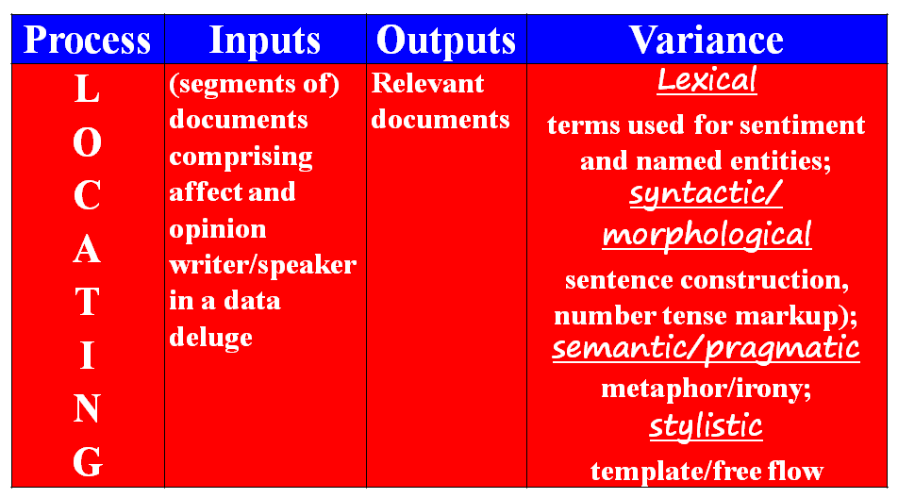

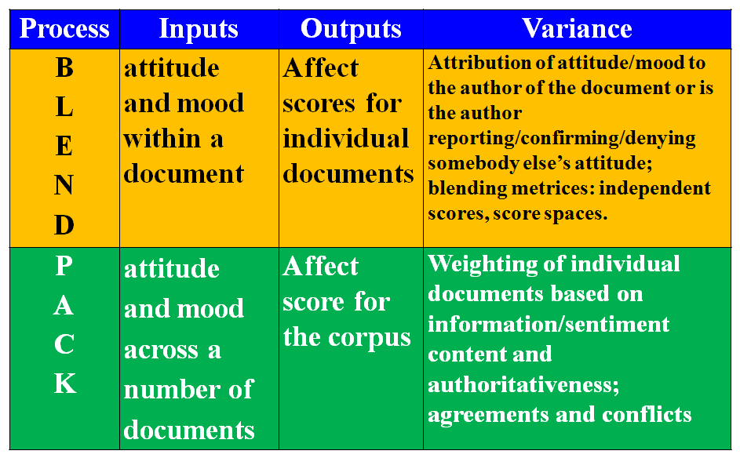

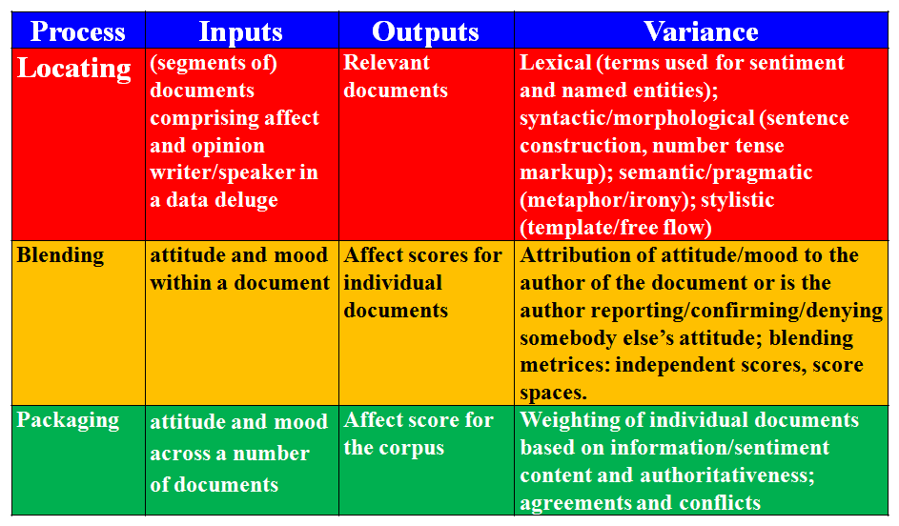

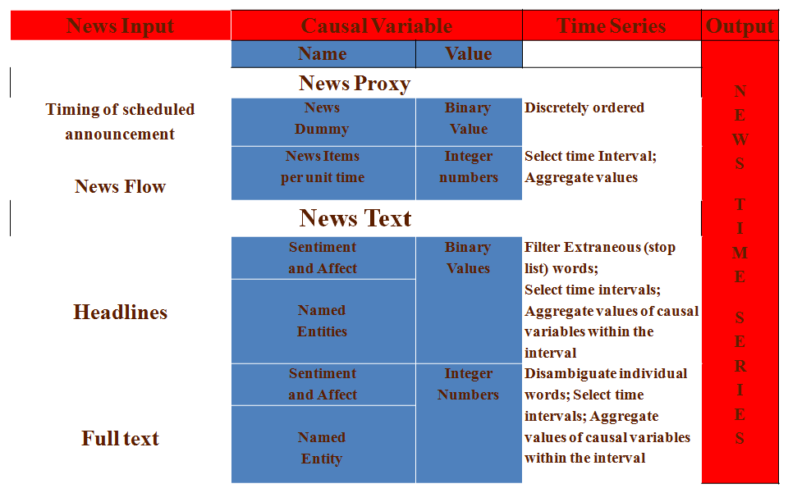

**Much of the work in economic and political sentiment analysis uses proxies – timings of key incidents, election results, dates of catastrophic events- and correlates with market behaviour or societal behaviour. Without reference to the discourse about the events.**

**Much of the work in information extraction deals with the discourse about the events (in blogs, newspapers) at different levels of linguistic description – lexical, syntactic, ‘semantic’. Without reference to the quantitative details related to the events – price movements, election results, death tolls, population dynamics.**

Equally puzzling, but more extensively studied, the persistence of volatility is another major feature that lacks an accepted explanation. While the direction of stock returns is generally unpredictable, their magnitudes are often very predictable. Stock markets repeatedly switch between periods of relative calm and periods of relative turmoil. This feature remains one of the most robust, and curious, in all of finance. Although much is known about the structure of volatility persistence, little is known about its causes. Similar to volume persistence, it is also a potential long-memory process. Beyond simple persistence there are some more complicated issues in the dynamics of volume and volatility.

Le Baron, Blake (2005). Agent-based Computational Finance. In (Eds.) F. Luna & A. Perrone, *Agent-based Theory, Languages, and Experiments*. London: Routledge Publishing. (Chapter 5)

One of the pioneers of political theory and communications in the early 20th century, Harold Lasswell, has used sentiment to convey the idea of an attitude permeated by feeling rather than the undirected feeling itself. (Adam Smith’s original text on economics was entitled A Theory of Moral Sentiments).

Laswell and colleagues looked at the Republican and Democratic party platforms in two periods 1844-64 and 1944-64 to see how the parties were converging and how language was used to express the change. Laswell created a dictionary of affect words (hope, fear, and so on) and used the frequency counts of these and other words to quantify the convergence.

**It has been argued by Robert Engle, the 1993 co-winner of the Nobel prize in economics, that ‘[a]s time goes by, we get more information on these future events and re-value the asset. So at a basic level, financial price volatility is due to the arrival of new information. Volatility clustering is simply clustering of information arrivals. The fact that this is common to so many assets is simply a statement that news is typically clustered in time.’ (1993:330).**

**Robert F. Engle III (2003). *RISK AND VOLATILITY: ECONOMETRIC MODELS AND FINANCIAL PRACTICE*. Nobel Lecture, December 8, 2003**



Notes on News Analytics

Khurshid Ahmad

January 2013-01-24

Tetlock has claimed that: (a) he has constructed ‘a simple measure of media pessimism from the contents of the *WSJ* [Wall Street Journal]’, and (b) has estimated intertemporal links between ‘this measure of media pessimism and the stock market using vector autoregression’ (2007:1140). The media pessimism was constructed by analysing a news-cum-opinion column in the *Wall Street Journal,*  called *Abreast of the Market* (AOTM): ‘AOTM is one of the most widely read market summary columns in the United States. It provides analysis of prior market activity, describes some notable company-specific events, and sometimes offers predictions for the future.’(Dougal et al 2012). Tetlock analysed the column and Dow Jones Industrial Average during a rather quiescent period 1984-1999, except for the 1987 crash – a total of3709 articles . More recent studies of the impact of sentiment on stock returns follows a similar line in selecting summaries of financial news from *WSJ* (ATOM), to investigate the bias of journalists writing the column (from 1970 to 1984, a total of 9552 articles, Dougal et al 2011), and news from *New York Times* (the columns “*Financial Markets*" column, and “Topics in Wall Street “from 1905 to 2005, a total of 55,307 articles, García 2012) for investigating the differential effects of negatives (and positive) sentiment during economic expansions and recessions. In both Dougal et al and Garcia, DJIA is used as a measure of stock returns. The lexica used in two studies (Tetlock 2007 and García 2012), are prescribed by the authors: Tetlock uses *General Inquirer* and the other two use Loughran and McDonald’s (2009) list of ‘financially’ relevant *positive* and *negative* words. Dougal et al focus on the journalists who produced the column and as such do not use estimates of affect via word count, rather for them it is the journalist who is the proxy for sentiments:t they relate “average returns to the day a particular journalist writes.” (Dougal et al 2012:

It has been argued, in a polemical account of the history of the US economy by Vatter and Walker (1996) that AOTM has been deliberately publishing misleading about certain stocks in the 1920’s (1996:409). Indeed, Dougal et al (2012) show that journalists have a negative or positive bias that reflects in their columns – and further claim that this has an impact on the performance of DJIA. Perhaps news-cum-opinion articles are influential in determining part of the performance of stock returns.

We have instead focussed on news articles carried in *New York Times* that contain terms related to *economy and economics* using an annotated digital library of NYT archives which is made available by the news vendors *LexisNexis.* The annotation is carried out by LexisNexis semi-automatically – keywords are extracted from each news item, and statistically relevant keywords are and then annotated digitally with the news item. Search algorithms then match the annotations to retrieve (statistically) ‘relevant’ news items. We have used the simple keyword search retrieval system within LexisNexis together one of the four classification systems offered by LexisNexis for constraining the serach. The system has a classification of subjects, ranging from *company activities, crime, economy and economic indicators* to *trade & development*, and industry classification that includes *aerospace & defence* to banking & finance, and from *retail sales* to *travel & hospitality.* (See Table I)News items can be grouped geographically and one retrieve documents that contain the name of an individual company. Each category in the LexisNexis classification scheme has subcategories and sub-sub-categories (see Table II). The search of LexisNexis can be constrained according to these categories and we have the assurance that we are dealing with text within a narrow domain. LexisNexis can create a corpus of news items, each with individual time stamp, from the archive –which incidentally comprise over 1500 newspapers published across the US and many more world-wide- and the archive is sent to the end user for analysis. We have used ‘United States’ as our geographic region and used two key words ‘economy’ and ‘economic’ to retrieve news items. We have not used the category classification except for the geographic reasons.There are two biases in this otherwise quasi-randomly data set: first, the choice of categories in that news items that do not contain the words/phrases chosen by LexisNexis annotators but comprise semantically related words/phrases will be excluded; second the choice of news publications – this is not compulsory, but we have chosen New York Times and that perhaps biases our choice of news.

The digital archives do contain ‘duplicates’: news items that either are exactly the same or contain variants of the same story. The variants could be corrections and updates; these variants are important as a news story evolves from the fog of an unexpected happening. Sometimes, though, news could just be repeated in-toto by accident or design to reinforce a message. If it is by accident then a keyword or affect word can be over-counted and given one basis point change in the frequency of a negative affect word can cause more than 4 basis drop in a stock return (Tetlock 2007:1149-1150), it is important to account for exact or near exact duplicates.

In Tetlock and others, DJIA return and detrended traded volume of stocks is used as a measure of movement in NYSE: the volatility in this index is taken into account by doing a series of transformations on the residual of DJIA (Tectlock 2007:1148); Dougal et al (2011) and Garcia (2012) use heteroskadistic estimates of volatility by estimating GARCH models. Dougal et al focus not on word counts but on the so-called journalist effect and have concluded that the analysis of S&P500 returns has the same result. If the market moves unexpectedly then perhaps one might use indices like VIX - the square-root of the risk neutral expectation of the S&P 500 variance over the next 30 calendar days. VIX has been popularly as an index of fear: however, as it is an aggregate of a range of options on the S&P500 perhaps VIX captures trader’s sentiment as well as the sentiment extracted from news reports and opinions about the market.

We look at

|  |  |
| --- | --- |
| Table I: Examples of classification schemes for news annotation in Lexis Nexis. Each ‘level’ is subdivided in ‘sub-levels’ keywords, prescribed by LexisNexis editors, are assigned to the level. When a news item comprises matching words/phrases within a (sub-) level, then the news item is assigned a given sub-level. | |
| Subject | Industry |
|  |  |

|  |
| --- |
| Table II: Sublevel classification in LexisNexis |
|  |

References

Casey Dougal, Joseph Engelberg, Diego García and Christopher Parsons[**Journalists and the Stock Market**](http://www.unc.edu/%7Egarciadi/paper86v12.pdf) *Review of Financial Studies*, 2012, 25(4), 639-679

Diego García(2012) [Sentiment during recessions](http://www.unc.edu/~garciadi/media_v33.pdf) (forthcoming) *Journal of Finance.*

Loughran, T., McDonald, B., 2009. \When is a Liability not a Liability?," Journal of Finance.

Vatter, Harold, G., and John F. Walker. (1996).(Eds). *History of the US Economy since World War II*

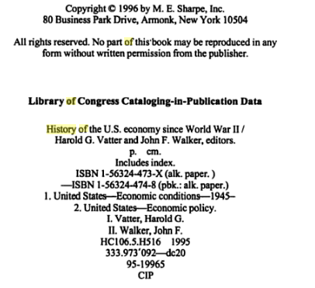

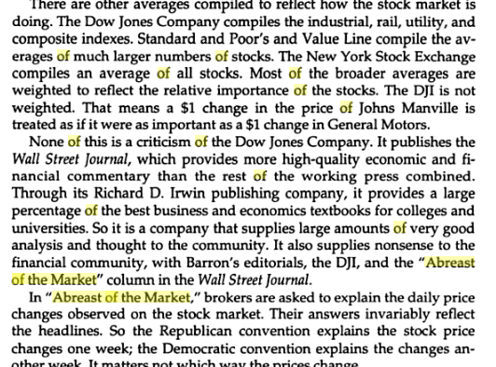

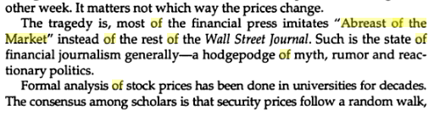

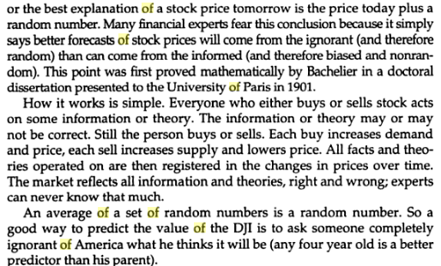

|  |
| --- |
| **Review: Automated Analysis of News to Compute Market Sentiment: Its Impact on Liquidity and Trading** |
| **Peer reviewer: Prof Khurshid Ahmad, Trinity College, University of Dublin, Ireland** |
| **Future of Computer Trading in Financial Markets’ Contact:** Piers Davenport – **0207 215 3872** |
| **Review:**  The work on the impact of news, especially affect and sentiment laden phrases within news items, on financial markets is critical for the well-being of economies large and small. The irrational behaviour (Kahneman and Tversky 1979, Kahneman 2002), contrarian behaviour (Shiller 2000), herd behaviour (Haiss 2010), and often irresponsible behaviour (Mackenzie 2009) of the various stakeholders in the financial markets, has demonstrated the limits of efficient market hypothesis (EMH) (Mandelbrot and Hudson 2004). It was the central tenet of EMH that news can be discounted by rational stakeholders. The 2008 *global* financial crisis was predicted by practitioner/academics (e.g.Taleb 2007), by serious financial polemicists (Roubini 2004) as well by key economic thinkers: Vernon Smith has noted that ‘historically, a recurrent theme in economics is that the values to which people respond are not confined to those one would expect based on the narrowly defined canons of rationality.’ (Smith 2008). It appears that prices and volumes cannot be determined by discounting news and rumours. The inclusion of (reports about and of) the behavior of the stakeholders in the market in price/volume models appears intuitively to be a ‘good thing’.  The advent of sophisticated computer systems, facilitating high frequency (HF) trading (Goodhart and O’Hara 1997) on the one hand, and providing access to and analysis of news, blogs and edicts from a variety of sources (Tetlock 2007, Ahmad 2011) on the other, suggests that financial traders will have access to enough information to make informed decisions very quickly – in tens of seconds (Iyengar and Ma 2010, have presented a theoretical model for incorporating news impact in HF trading). This advantage of HF trading is not limited to the trading floors only, indeed this trading will help to investigate ‘the effects of market structure on the availability and interpretation of the data, methodological issues such as the treatment of time, the effects of intra-day seasonals, and the effects of time-varying volatility, and the information content of various market data’ (Goodhart and O’Hara 1997). However, HF trading may also lead to instances of stocks dropping from $40 to one cent in a matter of seconds and in the same trading another stock rising from $6 to $99,999 (Mackenzie 2011 commenting on a curious price spike/fall on 6 May 2010; the author also makes the point about *algo(rithmic) sniffing* where software systems look at the behavior of a competitors’ high-frequency trading algorithms in the market.  The key point for me at least is that HF trading patterns can be discerned at different scales from tick-by-tick trades to daily, weekly, monthly or yearly scales. HF trading and other innovations in financial/economic systems ‘contain variables that operate on a variety of time-scales simultaneously so that the relationships between variables may well differ across time-scales’ (Ramsey 1999:2594): Using the wavelet approach Ramsey and Zhang (1997) have successfully analysed foreign exchange tick trade data.  The impact of news on financial markets can be substantial and, according to the Nobel Laureate Robert Engle (2002), asymmetric: the arrival of ‘bad news’ has a longer lasting effect on prices, and particularly on volumes of shares traded, when compared to the arrival of ‘good news’. Economists typically use proxies for the news content – change in the values of currencies, bonds, or aggregated indices like the Dow Jones, NASDAQ.  News was traditionally interpreted as a causal variable in financial market models: readily quantifiable aspects of news as a proxy for the news itself. The proxy includes the timing of news arrival, the volume of news items and the type of news (Antweiler and Frank 2004). News proxies were used with some effect to show that ‘negative’ news has much longer lasting impact than the positive news (Engle 2002, Engle & Ng 1991). This kind of sentiment analysis is almost always conducted post-hoc (Chang & Taylor 2003, Bauwens, Omrane and Giot 2005). Sentiment indices have been constructed using news proxies – in the context of equities it has been observed that ‘wave of investor sentiment has larger effects on securities whose valuations are highly subjective and difficult to arbitrage’ (Baker and Wurgler 2006). More recently, news proxies have been used in the analysis of the high frequency trading behaviour of German Bund futures: ‘news announcements have a highly positive impact on both efficient and noise volatility’ (Hautsch, Hess, and Veredas 2011).  News content analysis, rather than the use of proxies, is becoming more important recently. Continual records of market analysts’ opinions on commercial news channels shows that positive news has short term (1 minute) impact on prices but the negative news impacts for 15 minutes (Busse and Clifton 2002). It has been argued that the use of optimistic language in press releases of a firm appears to increase the firm’s future earnings, whilst pessimistic news has the opposite effect (Davies, Piger & Sedor 2006). Tetlock has shown that the negative affective component of news reports does have a longer lasting impact on the volatility of equities by analyzing opinion columns in financial news papers (Tetlock 2007). Groß-Klußmann and Hautsch (2011) have reported the impact of sentiment extracted from news streams on the patterns observed in high frequency trading using a VAR model for equity trading on the London Stock Exchange. The authors obtained ‘distinct responses in returns, volatility, trading volumes and bid-ask spreads due to news arrivals’ (2011:321). The results obtained by Groß-Klußmann and Hautsch depend critically on linguistic processing especially the pragmatic questions about the relevance of the news and the topics discussed therein.  The key to successful incorporation of sentiment in econometric models of financial time series, that are sometimes non-stationary, show GARCH effects, and have a scalar behaviour, requires an understanding of news and blogs at different levels of linguistic (Wilson, Wiebe& Hoffmann 2005) and ontological description (Valitutti, Strapparava & Stock 2004) . News agencies supply a vast quantity of undifferentiated general news and it is not clear what is the relationship between such news and a specific financial instrument or commodity. In order to use news specific to an instrument/commodity, it is important that a language processing system has access to the right terminology which is organised systematically under the rubric of an applications ontology. The next level of linguistic description is that of grammar and morphology which are essential for disambiguation – natural language is inherently vague and ambiguous and grammatical and morphological analysis can help in identifying and eliminating ambiguity (Rentoumi et al 2009). The higher level of linguistic description include semantic and pragmatics: sentiment bearing phrases comprise affect including evaluation (positive/negative), attitude (active/passive) and orientation, and are sometimes expressed metaphorically (Glucksberg 2001, Goatley 1997). Different types of texts – reportage, editorial, comments, blogs – require different kinds of analysis as these texts are structurally different and use different linguistic devices for communication.  One major problem in sentiment analysis is that of aggregation: sentiment in a text or blog is articulated within a phrase – one can assign a polarity evaluation to the phrase in a nominal sense. The question is how to aggregate the sentiment score of a set of phrases that comprise a text or blog? One can aggregate nominal values but what kind of a arithmetic will be used. Typically, this aggregation is carried out using multivariate analysis including factor analysis – but this analysis has its own limitations.  Similarly, the topic of a news story has to be determined and there are algorithms to do automatically perform such an assignment – but these algorithms have their own limitations and had to be used with some care as demonstrated by Groß-Klußmann and Hautsch (2011).  Goodheart and O’Hara (1997) do talk about the notion of time in trading: the cointegration of a news time series with prices/volumes time series is not easy to perform in that the dating of the news and that of prices are carried out using different conceptualisation of time. News affect can lag the prices (Tetclock 2007), but equally one can take the contrary view. In any case, the information in the news is absorbed in the prices once all stakeholders have access to the news – how will this absorption be incorporated in a combined news/price models.  **References:**  Ahmad, K. (2011) (Ed.), Affective Computing and Sentiment Analysis:Metaphors, Emotions and Terminology. Heidleberg, Springer Verlag, 200 pp  Antweiler, W., & Frank, M. Z..(2004) Is all that talk just noise? The information content of internet stock message boards. *Journal of Finance*, pp 1259-1294, 2004.  Baker, M., and Wurgler, J. (2006), Investor Sentiment and the Cross-Section of Stock Returns. *Journal of Finance*, Vol 59 (4), pp1645-1678.  Bauwens, L.; W.B. Omrane; and P. Giot. (2005). “News Announcements, Market Activity and Volatility in the Euro/Dollar Foreign Exchange Market.” *Journal of International Money and Finance*. Vol. 24, pp 1108-1125.  Busse, J. and T. Clifton Green. (2002). Market efficiency in real-time. *Journal of Financial Economics*, Vol. 65:¸pp 437  Chang, Y., and Taylor, S.J. (2003) Information Arrivals and Intraday Exchange Rate Volatility. *J. Int. Financial Markets, Institutions and Money*, Vol 13, pp85-112.  Davis, A.K., Piger, J.M., Sedor, L.M. (2006). *Beyond the numbers: An analysis of optimistic and pessimistic language in earnings press releases*. Technical Report, Federal Reserve, Bank of St Louis  Engle, R.F (2003) [Risk and Volatility: Econometric Models and Financial Practice](http://ideas.repec.org/p/ris/nobelp/2003_004.html)," [Nobel Prize in Economics documents](http://ideas.repec.org/s/ris/nobelp.html) 2003-4, Nobel Prize Committee, <http://nobelprize.org/nobel_prizes/economics/laureates/2003/engle-lecture.pdf>  Haiss, Peter (2010). ‘Bank Herding and Incentive Systems as Catalysts for the Financial Crisis’. *The IUP Journal of Behavioral Finance*. Vol 7 (Nos. 1 &2), pp 30-58.  Hautsch, N., D.Hess, David Veredas. (In Press). The impact of macroeconomic news on quote adjustments, noise, and informational volatility. *Journal of Banking and Finance*, doi:10.1016/j.jbankfin.2011.03.004.  Iyengar, G., Ma, Alfred Ka Chun. (2010). A behavioral finance-based tick-by-tick model for price and volume. *Journal of Computational Finance* Vol 14 (1), Fall 2010, pp57–80.  Kahneman, D & Tversky, A. (1979) Prospect Theory: An Analysis of Decision under Risk. *Econometrica*, Vol. 47 (No. 2) (Mar., 1979), pp. 263-292  Kahneman, D. A. (2002). Maps of Bounded Rationality: The [2002] Sveriges Riksbank Prize [Lecture] in Economic Sciences. ([http://nobelprize.org/nobel_prizes/economics/laureates/2002/kahnemann-lecture.pdf visited 14 April 2009](http://nobelprize.org/nobel_prizes/economics/laureates/2002/kahnemann-lecture.pdf%20visited%2014%20April%202009))  Mackenzie, Donald. (2009). All Those Arrows*. London Review of Books.* Vol. 31 No. 12 · 25 June 2009 pages 20-22.  MacKenzie, D. (2011). How to Make Money in Microseconds. *London Review of Books*. Vol. 33 (10), 19 May 2011, pp 16-18.  Mandelbrot, Benoit, B., & Hudson, Richard L. (2004). The (Mis)Behaviour of Markets. London: Profile Books  Goodhart, C.A.E., and M. O'Hara (1997). High frequency data in financial markets: Issues and applications. *Journal of Empirical Finance* Vol 4, pp 73-114  Ramsey, J.B., and Z. Zhang (1997). The analysis of foreign exchange rate data using waveform dictionaries. *Journal of Empirical Finance* Vol 4 341-372.  Ramsey J.B. (1999). The contribution of wavelets to the analysis of economic and financial data. *Phil. Trans. R. Soc. Lond. A* 357: 2593-2606.  Rentoumi, V., Giannakopoulos, G., Karkaletsis, V., & George Vouros (2009). Sentiment Analysis of Figurative Language using a Word Sense Disambiguation Approach. *Proceedings of the International Conference RANLP2009*  Stroudsburg: Association for Computational Linguistics, pp 370-375  Roubini, Nouriel., and Brad Setser (2004). Bailouts or Bail-ins?: Responding to Financial Crises in Emerging Economies.  Shiller, Robert. (2000). *Irrational Exuberance*. Princeton: Princeton University Press.  Smith, Vernon. (2008). Rationality in economics: constructivist and ecological forms. Cambridge: Cambridge Univ. Press.  Taleb, Nassim Nicholas (2007). *The Black Swan: The Impact of the Highly Improbable.* London: Penguin Books.  Tetlock, Paul C. (2007). Giving Content to Investor Sentiment: The Role of Media in the StockMarket. *Journal of Finance*. June 2007, Vol. 62 (No. 3), pp 1139-1168.  Valitutti, A. (2004). WordNet-Affect: an Affective Extension of WordNet. *Proceedings of the 4th International Conference on Language Resources and Evaluation* (2004) (available at <http://wndomains.itc.it/publications/lrec2004.pdf>)  Valitutti, A., Strapparava,C., & Stock,O. (2004) Developing Affective Lexical Resources. *PsychNology Journal*, Vol 2 (1), pp 61-83  Wilson, T., Wiebe, J., & Hoffmann, P. (2005). “Recognizing Contextual Polarity in Phrase-Level Sentiment Analysis.” *Proc. Conf. on Human Language Technology and Empirical Methods in Natural Language Processing* Vancouver, British Columbia, Canada. pp 347-354  Glucksberg, S. (2001). *Understanding Figurative Language: From Metaphors to Idioms*. Oxford: Oxford University Press.  Goatly, A. (1997). *The Language of Metaphors.* London: Routledge. |
| **Comments on balance of current science and future challenges:**  This document under review is focussed on the current understanding of financial markets. The future challenges are not discussed in much depth and the current science not reviewed critically. Here are some examples:   1. Sections 1 and 2: There is no reference to the considerable work on *behavioural finance* – this really is a pre-requisite for thinking about sentiment. Sentiments relate to *irrational exuberance* and are related to motivations and belief. The stakeholders do behave rationally generally, but switch over to irrational behaviour when, for instance, faced with deliberately framed propositions designed to provoke risk seeking or risk averse behaviour. 2. Section 2. The frequency of trade cannot always match the frequency at which the news arrives. This is a serious problem of aligning news with asset trading patterns. (This problem is revisited in Section 5.3 but no more details are forthcoming there as well.) 3. Section 2. The description of asset classes ignores any interdependence on different asset classes that may be traded in different markets – *commodity futures* may show short-term interaction with equities of enterprise involved in trading the given commodity – for example *oil futures* and *oil company* equities. The interdependence within the same asset classes is not discussed either. The linguistic analysis will have to be much broader for inter-dependent classes than will be the case for one asset class. 4. Sections 2 & 3. High frequency trading patterns can be decomposed at different scales – there are good examples where scale-based analysis has shown to be quite effective and objective as well. No reference to HF literature discussing wavelets. 5. Section 3. It is not clear where the discussion of market microstructure helps us in carrying out sentiment analysis. 6. Section 4. Trader typology is an interesting one but takes a rather romantic view of a typical trader on a real or virtual trading floor: The traders seldom have time look at the news – much of the focus is on numerical information and numerical analysis of time series which is displayed on four or more monitors. News is streamed like the strapline on news channels. It will be useful to discuss the results of what strategies traders use. Traders have access to their communal blogs and appear to read such documents more frequently during breaks or after hour. 7. Section 5. The overview is very academic – traders reading news and analysing the news- and quite optimistic when the authors argue that ‘application of these news data will lead to improved analysis’ (pp19). The optimism continues when they argue that news analytic technologies will ‘automate human thinking and reasoning’ 9pp 20). 8. Section 5 – Sentiment Analysis Systems: There appears to be much reliance on statements by organisation involved in selling sentiment analysis systems. This reliance may be justified but there are other systems on the market and a comparison with the cited systems (Raven Pack) will be beneficial for the Foresight Programme. There should be more discussion of how, for example, Reuters/RavenPack compute negative/positive, and more importantly neutral sentiment, how relevance is calculated. All these scores and metrices are presented without much evaluation or commentary. 9. Section 6 News Analytics and Market Sentiment: The preamble of this section is a commentary based on anecdotal details of major events – 1987 crash, reflation of US economy, banking frauds and scandals. The authors cite some papers that may have shown the relationship between sentiment and prices and second moments like volatility – but no conclusion is drawn ( e.g. Mitchel and Mullherin 91994) and Ranaldo (2008) consider the impact of news on intraday trading activities.’ AND? Similar treatment was given to Tetlock eta l in Section 5.3). 10. Section 7. News analytics and its application to trading. This section deals with trading strategies rather than with sentiments. The authors should write something about news proxies, especially news flow, that have been sued to build a number of complex models for analysis and prediction. |
| **Structural changes or grammatical errors:**  The document needs revision and the authors should perhaps collate the literature review and motivational aspects of this report into one section. The literature review should be up-to-date – in my review section I have attempted to do just that. There must be a section on a comparative evaluation of existing sentiment analysis systems; attention should be paid to how news proxies are used for computing sentiments. There is little about the information extraction/natural language processing techniques being adapted for sentiment analysis . Finally there should be a section on what the authors are proposing by way of new science and new challenges: Here the flow chart/architectures presented in Figures 5.1, 6.1 and 7.1 can form the basis of this new section.  The grammar, spelling and punctuation are good. |
| **Recommendations (with comments please)**  **a)Accept the view unconditionally**  **b)Accept the view providing the author(s) consider and incorporate**  **comments outlined in the peer review**   1. **Please update your literature review; please outline strengths and weaknesses of news proxies** 2. **Human behaviour impacts financial markets and vice versa. If you think this is the case then there must a critical assessment of literature on behavioural finance.** 3. **Be more searching and critical about sentiment analysis system;** 4. **Please propose an integrated system for automated system for automated analysis of news and price/volume analysis.**   **c) Reject the view completely** |

|  |  |
| --- | --- |
| Why be Quantitative?*H. Lasswell* | complete survey of mass attention will go far beyond the press, the broadcast or the film. |
| Tetlock et al (2008:1438) | Before delving into our tests, we call attention to two significant advantages to using the language in everyday news stories to predict firms’ earnings and returns. First, by quantifying language, researchers can examine and judge the directional impact of a limitless variety of events, whereas most studies focus on one particular event type, such as earnings announcements, mergers, or analysts’ recommendations. Analyzing a more complete set of events that affect firms’ fundamental values allows researchers to identify common patterns in firm responses and market reactions to events. Equally important, examining all newsworthy events simultaneously limits the scope for “dredging for anomalies”—the phrase used by Fama (1998) to describe running event studies on different types of events until one obtains “significant” results.  Second, linguistic communication is a potentially important source of information about firms’ fundamental values. Because very few stock market investors directly observe firms’ production activities, they get most of their information secondhand. Their three main sources are analysts’ forecasts, quantifiable publicly disclosed accounting variables, and linguistic descriptions of firms’ current and future profit-generating activities. If analyst and accounting variables are incomplete or biased measures of firms’ fundamentals, linguistic variables may have incremental explanatory power for firms’ future earnings and returns. |
| Tetlock (2008:1439) | Rather, we investigate whether the fraction of negative words in firm-specific news stories can improve our understanding of firms’ cash flows and whether firms’ stock market prices efficiently incorporate linguistic information. Insofar as negative word counts are noisy measures of qualitative information, the coefficients in our regressions should be biased toward zero, understating the true importance of qualitative information.  First, Qualitative verbal information does not merely echo easily quantifiable traditional measures of firm performance  Second, stock market prices respond to the information embedded in negative words with a small, one-day delay  we identify potential profits from using daily trading strategies based on the words in a continuous intraday news source (*DJNS*), but not from strategies based on a news source updated less frequently (*WSJ*).  we separately analyze negative words in news stories whose content focuses on firms’ fundamentals. We find that negative words in stories about fundamentals predict earnings and returns more effectively than negative words in other stories. Collectively, our three findings suggest that linguistic media content captures otherwise hardto- quantify aspects of firms’ fundamentals, which investors quickly incorporate into stock prices. |
| Tetlock (2008:1440) | We make the simplifying assumption that all negative words in the predetermined dictionary are equally informative, and other words are uninformative.  We rely on extensive psychological research to identify negative words, thereby avoiding this daunting estimation task and the need for subjective human judgment. Our resulting word count measures are parsimonious, objective, replicable, and transparent.  Our study is most closely related to concurrent work by Li (2006) and Davis, Piger, and Sedor (2006), who analyze the tone of qualitative information using objective word counts from corporate annual reports and earnings press releases, respectively |
|  | Firms in the S&P 500 index encompass roughly three-quarters of the total U.S. market capitalization, and appear in the news sufficiently often to make the analysis interesting. |
|  | We focus on news stories featuring the company name most directly related to the stock. Thus, for conglomerates, we use the holding company name, not the subsidiary names—for example, PepsiCo, Inc., or Pepsi for short, rather than Gatorade or Frito-Lay. This means that we may miss news stories about some firms’ major products, possibly weakening our results.  Our source for news stories is the Factiva database. |
| Pp 1142 | In total, we retrieve over 350,000 qualifying news stories—over 260,000 from *DJNS* and over 90,000 from *WSJ*—that contain over 100,000,000 words. We find at least one story for 1,063 of 1,110 (95.8%) of the firms in the S&P 500 from 1980 to 2004 (see the Appendix for details). We include a news story in our analysis only if it occurs while the firm is a member of the S&P index and is within our 25-year time frame.  Each of the stories in our sample meets certain requirements that we impose to eliminate irrelevant stories and blurbs. Specifically, we require that each firm-specific story mentions the firm’s official name at least once within the first 25 words, including the headline, and the firm’s popular name at least twice within the full story. In addition, we require that each story contains at least 50 words in total, and at least 5 words that are either “Positive” or “Negative,” where at least 3 of the 5 must be unique. We impose these three word count filters to eliminate stories that contain only tables or lists with company names and quantitative information, and to limit the influence of outliers on the negative words measure described below. |
| Pp 1143 | Before counting instances of negative words, we combine all qualifying news stories for each firm on a given trading day into a single composite story. We standardize the fraction of negative words in each composite news story by subtracting the prior year’s mean and dividing by the prior year’s standard deviation of the fraction of negative words. Formally, we define two measures of negative words:  The standardization may be necessary if *Neg* is nonstationary, which could happen if there are regime changes in the distribution of words in news stories—for example, the *DJNS* or *WSJ* changes its coverage or style. The variable *neg* is the stationary measure of media content that we employ in our regression analyses. |
| Pp 1143-1144 | We now formally investigate whether the language used by the media provides new information about firms’ fundamentals and whether stock market prices efficiently incorporate this information. In order to affect stock returns, negative words must convey novel information about either firms’ cash flows or investors’ discount rates (Campbell and Shiller (1987)). Our tests in this section focus on whether negative words can predict earnings, a proxy for cash flows, and therefore permanent changes in prices. The return predictability tests in Section IV address the possibility that negative words proxy for changes in investors’ discount rates, and therefore lead to return reversals. The idea underlying our earnings predictability tests is that negative words in a firm’s news stories prior to the firm’s earnings announcement could measure otherwise hard-to-quantify unfavorable aspects of the firm’s business environment. |
| Pp 1145 | Our measure of negative words (*neg*−*30*,−*3*) is the standardized number of negative words in all news stories between 30 and 3 trading days prior to an earnings announcement divided by the total number of words in these news stories. That is, we construct the measure exactly analogous to the story-specific measure (*neg*) defined earlier, where we treat all the words in the [–30,–3] time window as though they form a single composite news story. We standardize *neg*−*30*,−*3* by subtracting the prior year’s mean and dividing by the prior year’s standard deviation. |
| Pp 1145-1146 | In all earnings predictability regressions, we include control variables based on a firm’s lagged earnings, size, book-to-market ratio, trading volume, three measures of recent stock returns, analysts’ earnings forecast revisions, and analysts’ forecast dispersion. We measure firms’ lagged earnings using last quarter’s *SUE* or *SAFE* measure, depending on which of these two variables is the dependent variable in the regression.8 We measure firm size (*Log(Market Equity)*) and book-to-market (*Log(Book/Market)*) at the end of the precedingcalendar year, following Fama and French (1992). We compute trading volumeas the log of annual shares traded divided by shares outstanding (*Log(Share Turnover)*) at the end of the preceding calendar year. |
|  | Our three control variables for a firm’s past returns are based on a simple  earnings announcement event study methodology.9 We estimate benchmark  returns using the Fama-French (1993) three-factor model with an estimation  window of [–252,–31] trading days prior to the earnings announcement. We include  two control variables for a firm’s recent returns, the cumulative abnormal  return from the [–30,–3] trading day window (*FFCAR*−*30*,−*3*) and the abnormal  return on day –2 (*FFCAR*−*2*,−*2*). These return windows end 1 trading day after  our [–30,–3] news story time window to ensure that we capture the full price  impact of the news stories. Our third control variable, *FFAlpha*−*252*,−*31*, is the  estimated intercept from the event study regression that spans the [–252,–31]  time window.We interpret the *FFAlpha*−*252*,−*31* measure as the firm’s in-sample  cumulative abnormal return over the previous calendar year, skipping the most  recent month. The *FFAlpha*−*252*,−*31* variable is related to the Jegadeesh and Titman  (1993) return momentum effect, which is based on firms’ relative returns  over the previous calendar year excluding the most recent month. |
|  | Even though the stock return control variable (*FFCAR*−*30*,−*3*) includes all of the information embedded in news stories during the [–30,–3] time window, it is possible that these stories are more recent than the most recent analyst forecast data. Indeed, many *WSJ* and *DJNS* news stories explicitly mention stock analysts, suggesting negative words in these stories may draw some predictive power from analysts’ qualitative insights. To guard against the possibility that negative words predict returns solely because they appear more recently than the *quantitative* analyst forecasts, we also calculate a “Before Forecasts” negative words measure (*neg*−*30*,−*3*) that includes only the stories that occur at least 1 trading day prior to the date of the most recent consensus analyst forecast. |
| Pp 1149 | Surprisingly, Columns 4 and 6 in Table I reveal that negative words and recent stock returns have almost the same statistical impact and comparable economic impacts on future earnings. After standardizing the coefficients to adjust for the different variances of the independent variables, we find that the economic impact of past returns is 0.127 *SUE* and the impact of negative words is 0.063 *SUE*—roughly half as large.We infer that incorporating directly quantified language in earnings forecasts significantly improves upon using stock returns alone to quantify investors’ reactions to news stories. |
|  |  |
| Pp 1154 | We now analyze the *Return*+*1*,+*1* and *FFCAR*+*1*,+*1* regressions that include stories from the *DJNS* (in Columns 2 and 5 of Table II) in greater detail. As one would expect in an efficient market, very few control variables predict next-day returns, which is why the *R2* statistics in Table II are so low. Aside from the daily news and returns variables, only firms’ earnings (*SUE*) have predictive power at the 1% level. |
|  |  |
| Pp1160 | The key stylized facts documented thus far are: (1) news stories about firms are concentrated around their earnings announcements; (2) negative words in firm-specific stories predict low firm earnings in the next quarter; and (3) negative words about firms predict low firm stock returns on the next trading day. |

Maik Schmeling (2009). Investor sentiment and stock returns: Some international evidence ☆

Journal of Empirical Finance. Volume 16, Issue 3, June 2009, Pages 394–408

We examine whether consumer confidence – as a proxy for individual investor sentiment – affects expected stock returns internationally in 18 industrialized countries. In line with recent evidence for the U.S., we find that sentiment negatively forecasts aggregate stock market returns on average across countries. When sentiment is high, future stock returns tend to be lower and vice versa. This relation also holds for returns of value stocks, growth stocks, small stocks, and for different forecasting horizons. Finally, we employ a cross-sectional perspective and provide evidence that the impact of sentiment on stock returns is higher for countries which have less market integrity and which are culturally more prone to herd-like behavior and overreaction.

**1.3 Investor sentiment proxies**

P 303-304

Three investor sentiment proxies are used in the empirical tests. The first proxy is a popular sentiment index based on *Investors Intelligence*’s weekly surveys of approximately 150 investment newsletter writers. Each newsletter is read and marked as bullish, bearish, or neutral, based on the expectations of future market movements.9 Following Brown and Cliff (2004, 2005), the bull-bear spread— the fraction of bullish investors minus the fraction of bearish investors—is used as a proxy for sentiment of large investors such as institutions. This is because many of the authors of these newsletters are current or retired market professionals. The bull-bear spread is published weekly in *Barron’s* and is often mentioned in the financial press. It is related tomany other measures of investor sentiment (Brown and Cliff, 2004). It is also positively related to deviations of large-size firms from their intrinsic values (Brown and Cliff, 2005).

The second investor sentiment proxy is derived from trading activity in the S&P 500 futures. The Commodity Futures Trading Commission (CFTC) requires large traders holding positions above a specified level to report their positions on a daily basis. The CFTC aggregates reported data, and releases the breakdown of each Tuesday’s open interest in the Commitments of Traders Report.10 The report contains the number of long positions and the number of short positions for both “commercial” traders and “noncommercial” traders. Commercial traders are required to register with the CFTC by showing a related cash business for which futures are used as a hedge. The noncommercials are large speculators. The second sentiment proxy is the net position of large speculators in S&P 500 futures, which is calculated as the number of long noncommercial contracts minus the number of short noncommercial contracts, scaled by the total open interest in S&P 500 futures.

The third investor sentiment proxy used is Sharpe’s (2002) valuation errors of the S&P 500 index. These errors are the fractional deviation of the S&P 500 index from the level predicted by the log-linear dynamic growth model of Campbell and Shiller (1988). They are the residuals of the log price-earnings ratio of the S&P 500 index regressed on earnings growth expectations, log dividend payout, and several other variables such as expected inflation and real 30-year treasury-bond yield. Positive (negative) error means that according to the Campbell-Shiller model, the S&P 500 index was overvalued (undervalued) relative to the fundamentals. For example, Sharpe finds that the stock index was grossly overvalued during August and September of 1987, just prior to the stock market crash in October 1987. On the other hand, the S&P 500 index was undervalued by more than 10% from late 1990 to early 1991, from late 1995 to early 1996, and around September of 1998.

Jeffrey Wurgler. Introduction: A special issue on investor sentiment Journal of Financial Economics104 (2012) 227

What is investor sentiment? Most definitions involve non-Bayesian beliefs about risks and returns or the use of nontraditional preferences. But this is just the comple- ment of traditional finance, and therefore, the boundary is equally fuzzy. As any research area develops, its vocabulary becomes more scientific as new concepts are absorbed. ………

I will not try to summarize the articles in this issue. An integrated discussion would be difficult in any case because the topics range from exploratory empirical work to theory involving agents with some aspect of sentiment.

The concepts employed are as diverse as media, social communication, geographic accident, cognitive complex- ity, attention, global contagion mechanisms, intelligence, primitive sources of utility, practical sentiment indicators, anchoring and extrapolation and categorization, and interactions thereof. The applications range from indivi- dual investor behavior to worldwide crises. It is clear that however one draws the boundary between different approaches of research today, the frontiers of finance as a whole are expanding rapidly.

Malcolm Baker, JeffreyWurgler, YuYuan (2012). Global, local, and contagious investor sentiment. Journal of Financial Economics 104 (2012) 272–287

Pp 273-274

A single ‘‘global’’ sentiment series is then estimated as the first principal component of these total sentiment series. Finally, each market’s ‘‘local’’ sentiment is estimated as the residual of its total sentiment regressed on global sentiment

The first proxy is a quantity that we refer to as the volatility premium and simply identifies times when valua- tions on high idiosyncratic volatility stocks are high or low relative to valuations on low idiosyncratic volatility stocks. This is by analogy to Baker and Wurgler’s (2004) use of the U.S. dividend premium, which, as the relative valuation of dividend- and non-dividend-paying stocks, is highly related (inversely) to the U.S. volatility premium.

The volatility premium (PVOL) is the yearend log of the ratio of the value-weighted average market-to-book ratio of high volatility stocks to that of low volatility stocks. High (low) volatility denotes one of the top(bottom) three deciles of the variance of the previous year’s monthly returns, where decile breakpoints are determined countrybycountry.3 Total volatility is defined as the standard deviation of the trailing 12 months of monthly returns, and to control for any association with beta and a confusion with priced risks, we compute the volatility premium based only on beta-adjusted idiosyn- cratic volatility (for simplicity, however, we will continue to refer to this variable as the volatility premium). This variable was available for all years and all countries. On average in our sample, the market-to-book ratio of high volatility stocks has been higher than that of low volatility stocks, but in each country this relationship has been reversed within our time period

The second and third proxies we employ are derived from initial public offering (IPO) data. They are the total volume of IPOs and their initial, first-day returns (some- times called underpricing). The theoretical motivation for using the volume of IPOs is simply that insiders and long- run shareholders have strong incentives to time the equity market for when valuations are greatest, which is presumably when sentiment is highest. Low long-run returns to IPOs have been noted by Stigler (1964), Ritter (1991), and Loughran, Ritter, and Rydqvist (1994), which is ex post evidence of successful market timing relative to a market index. But issuers need not care that much whether their firm’s misvaluation is due to firm-specific or marketwide factors; consistent with that notion, equity issues as a fraction of total new issues forecast low market returns as well (Baker and Wurgler, 2000). The worst future returns occur for IPOs and equity issues from ‘‘hot market’’ cohorts with high total issuance volume.

The number of IPOs(NIPO) is the log of the total number of IPOs that year. the initial returns on IPOs (RIPO) are the average initial (most of ten, first-day) return on that year’s offerings. the returns are equal-weighted across firms. the data were obtained from a variety of sources. We were able to find both variables for the full sample with the exception of Francefor1980through 1982 andGermanyfor2003through2005.In the United States, the annual number of IPOshasrangedfrom64to 953 in the sample period, and the average first-day return on IPOshasrangedfromaround7%toahigh of 70% (exponentiate the Min and Max values from Table 2), as noted above. Most othe r countries have also seen high variation in these quantities.





April Knill, Kristina Minnick, & Ali Nejadmalayeri (2006). Selective Hedging, Information Asymmetry, and Futures Prices*. Journal of Business*, 2006, vol. 79, no. 3, pp 1475-1500.

Abstract: Evidence from hedging practices suggests that firms will hedge only if they expect that unfavorable events will arise. In markets with a significant degree of information asymmetry in which hedgers are oligopolists with superior knowledge concerning supply and demand, such as oil and gas futures, we contend that these companies will selectively hedge price movements, causing sharp price adjustments upon resolution of information asymmetry. Using aggregate analysts’ surprise as a proxy for the degree of information asymmetry, we show that positive aggregate surprises lead to a price decline for futures, which indicates that these firms unload their futures when the outlook is favorable.

P 1476: However, as the classical Grossman-Stiglitz (1980) argument and its critique goes, if uninformed traders can make inferences about informed traders’ information through either price movements or other channels, they will adjust their demands for assets accordingly, which will give rise to a fully revealing equilibrium.

Our results indicate that an analyst’s forecast does affect futures prices significantly negatively. In line with predictions of a selective hedging theory, our results suggest that oil and gas companies use futures primarily to hedge their spot commodity positions. When the firms’ outlook and, consequently, the prospects of profitability improve, they reduce their hedge positions. When the improved industry outlook is revealed at the earnings announcements, the other market participants react accordingly, leading to fewer long positions in futures and hence depressing the futures prices. Indeed, we find that positive earnings surprises for less integrated companies, such as oil and gas producers and explorers, have more pronounced effects on futures prices. Note that since nonintegrated oil and gas companies (e.g., production and exploration firms) cannot operationally hedge the commodity price risk, they are more likely to use financial contracts such as futures for hedging.

Contributions: 1: aggregate positive earnings surprise in the oil and gas industry leads to selloffs in the oil and gas futures markets; 2: Knill argues that macroecnomic factors have been suggested to be the cause of changes in commodity prices. But she argues that: “Given the fact that earnings surprises can reflect industry and company outlooks, analyst forecasts can then be used as predictive factors of futures prices.” (2006:1478); 3: Knill claims that she “can show whether analysts’ forecasts incorporate private information and affect

security prices”.

Proxy: Dates of earning announcements

Conclusion: We test our central hypothesis by examining whether analyst forecast error as a measure of information asymmetry affects futures prices or not. If oil and gas companies use futures contracts to selectively hedge risk, they hedge only the downside risk. When industry outlook is good (bad), they will scale down (up) on their futures usage, hence pushing futures prices higher (lower). We find that, indeed, aggregate earnings surprises negatively affect the futures prices, confirming our conjecture that in “good times” oil and gas companies will not use as many futures contracts. The impact of this on futures prices implies that microeconomic factors such as expected firm performance affect commodity prices and that analyst estimation does have implications on futures prices.